**Segmentation and analysis of sound files VCVP**

Maud Westendorp

December 2018

! = click (R! = right click)

[] = button

Step 0. Praat

*Starting with automatically creating a TextGrid in Praat will help speed up the segmentation process, but this step can be skipped.*

1. Open soundfile with Praat.
2. ![Annotate] !To TextGrid (silences)…
3. Choose the following settings. ![OK]

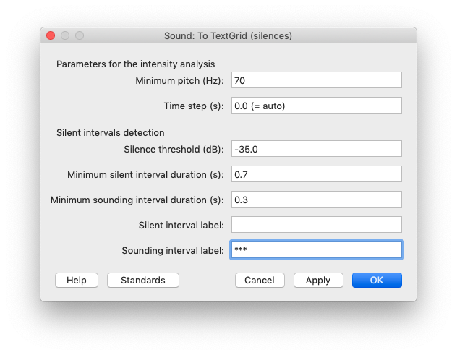

1. Select TextGrid object !Save !Save as text file… ![Save]

Step 2. ELAN

*In this step we import the TextGrid into ELAN and combine it with the sound file. NB! Start with an empty ELAN screen.*

1. !File !Import > !Praat TextGrid File…
2. ![Browse] select TextGrid file ![Open] ![OK] (Encoding: UTF-8)
3. !Skip empty intervals / annotations ![Next] ![Finish] ![OK]
4. !Edit !Linked Files…
5. ![Add…] select wav file ![Open] ![Apply]

*With the sound file in place, set up the transcription.*

1. !Options !Transcription Mode…
2. Select type for column > praat ![Apply]
3. You will now have a large number of rows in the Transcription Mode window, probably around 200. This will end up being reduced to 136 items (Kongsbakken EmbMain) (or appropriate # for experiment).

*Segmenting the sound file.*

1. !Options !Segmentation Mode…
2. Delete all non-test item annotations (chat and test round in the beginning and middle of the recording plus chat at the end) and adjust the others so that you end up covering all 136 items.

* Deleting an annotation is done by hovering over the black line until it turns green and then pressing Delete or Backspace. Adjust by dragging.
* Make a new annotation by clicking in the spectrogram in a place where you want the annotation to start, press Enter, click at your preferred end point, press Enter again.
* Merging two annotations is done by hovering over the first and ctrl/cmd + shift + a (or R! on annotation > Merge With Next Annotation).
* Split an annotation that is covering two items by R! annotation > Split Annotation.

*Exporting from ELAN to Excel*

1. !File !Export As.. > !Tab-delimited Text
2. Use the following settings/check the following boxes: 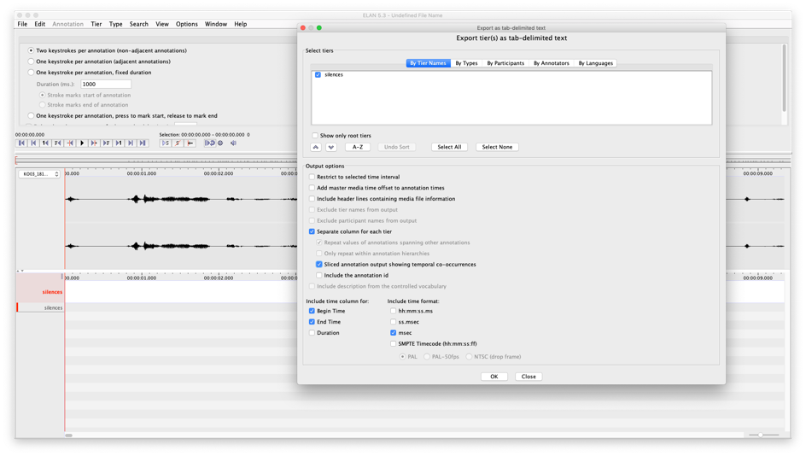
3. ![OK] choose file name, save (this file can be deleted later) ![Save] ![OK]

Step 3. Excel

1. Open the .csv file you just made. Open the .xslx-file for the participant as well. Copy the information about the order of test items from columns I and J (“annotation” and “tier”) into the .csv-file in place of the “silences” column. Save as .csv. It will look like something like this:

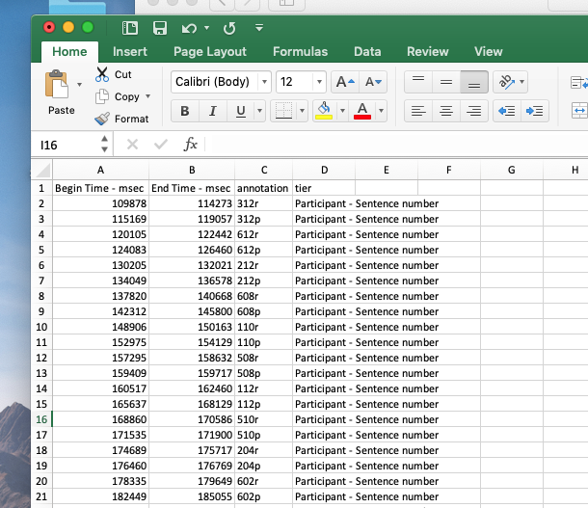

Step 4. ELAN (again)

*NB! Start with an empty ELAN screen.*

1. !File !Import > !CSV / Tab-delimited Text File…
2. ![Browse] select the .csv file you created in the previous step ![Open]
3. Fill out the import options. ![OK]

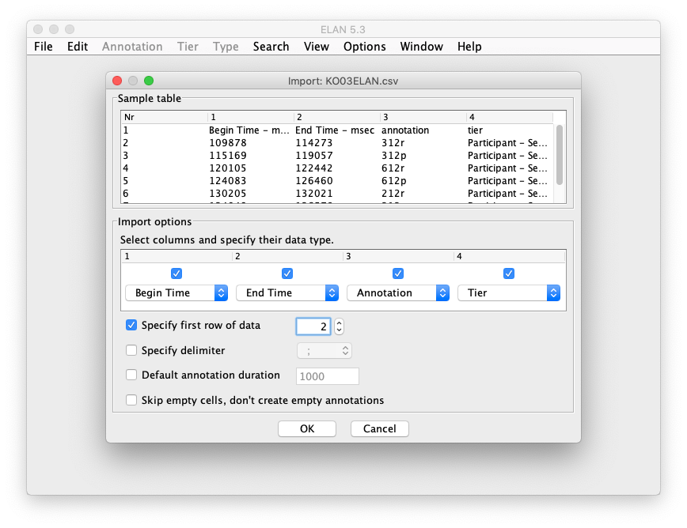

1. !Edit !Linked Files…
2. ![Add…] select wav file ![Open] ![Apply]
3. !Tier !Import Tiers… ![Browse] select ELANTemplate.etf ![Open] ![Import]
4. You can now start transcribing/annotating the data! (!Options !Transcription Mode…)